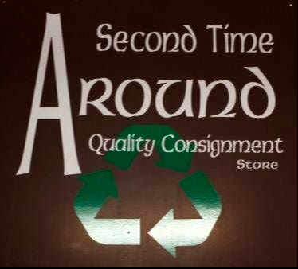

Second Time Around

Quality Consignment Store

04.19.2019

_________________________________________________

Presented by: Lexy Koltermann, Kiersten Popodi, Victoria Arjani

Table of Contents

Research Opportunities and Insights ……………………………………………...…3

Research Design ……………………………………………………………...……….5

Data Collection Method …………………………………………………………...…...6

Sampling Plan ……………………………………………………………………….….10

Data Collection Process ………………………………………………………….….11

Analysis Plan ………………………………………………………………………….13

Conclusion …………………………………………………………………………….20

Resource Page ………………………………………………………………………...21

**RESEARCH OPPORTUNITIES AND INSIGHTS**

**Introduction:**

We are students from Western Technical College majoring in Digital Marketing and Marketing Management. When we spoke during our consultation, we asked questions about your business. We would like to thank you for taking the time and answering those for us! Going forward with our Marketing Research class we would like to work with your company for our Marketing Strategy Project.

The beginning date would be March 5th and the ending date would be April 14th, at this time we will keep in touch with updates and introduce our ideas and data.

*Note: Information related to/references thrift stores and consignment stores are used as a blanket term and still do apply to Second Time Around

**Company/Competitors**

Second Time Around has been around for 33 years, co-founded by Ruth and later handed down to Julie who has been running the store for 10 years. This local consignment store is located in Viroqua, WI.

* Julie states that her local competitors would be Mr.G's, Piece of the Past, Walmart, and BonTon.

Internet Information Below:

Online there were reviews, mostly positive and a video stating that Second Time Around is a hidden treasure.

**What we found for competitors below:**

|  |  |  |  |  |
| --- | --- | --- | --- | --- |
| Local | KEPS | Piece of the past | Mr. G’s | BonTon |
|  | Treasure on Main | Elite Retreat | Viroqua Thrift Store | Goodwill |
|  | The Ole Red Shed | Sparta Antique | Sparta Boutique | Walmart |
| Online | eBay | Craigslist | Poshmark | Etsy |

**Customers**

Interview Information Below:

**Demographic**: 45-65 Males 30-65 Females

**Psychographic**: Regulars come two times a week, Themes of the week (come in twos)

**Usage/Behavior**: 75% of customers buy, Women clothes and household items are the best sellers

Internet Information Below:

**Demographic:** 24-45 of Viroqua

**Psychographic:** Lower-income families and older people with no kids. Looking for deals/bargain prices, looking for eco-friendly ways to repurpose clothing.

Current Advertising Methods:

|  |  |  |
| --- | --- | --- |
| Facebook (Free) | Radio ($5.00) | Newspaper ($22.00) |

**Climate/Content**

Interview Information Below:

* Second Time Around is a Consignment store
* Weather affects consumers' foot traffic.
* Crazy Days (a Viroqua city sale) drives traffic.

Internet Information Below:

* Eco and ethical fashion are on the rise, which buying second hand is considered.
* Resale/consignment/ thrift stores are becoming a trend with younger generations (16+), through an effort to both save money and become eco-friendlier through recycling and repurposing clothing.
* Most times, when someone walks into a consignment /second-hand store, they are looking for a unique find or a good deal.

TRENDS IN SECOND-HAND STORES

Links to these articles can be found on the resource page under the trends section.

* According to Forbes, second-hand stores are scaring discounted stores like Ross Dress for Less, and Tj Maxx because of their recent gain in popularity.
* According to Thredup, the second-hand apparel market is to double in the next five years. - - Also 18-37-year-old are the fastest-growing group of second-hand shoppers. 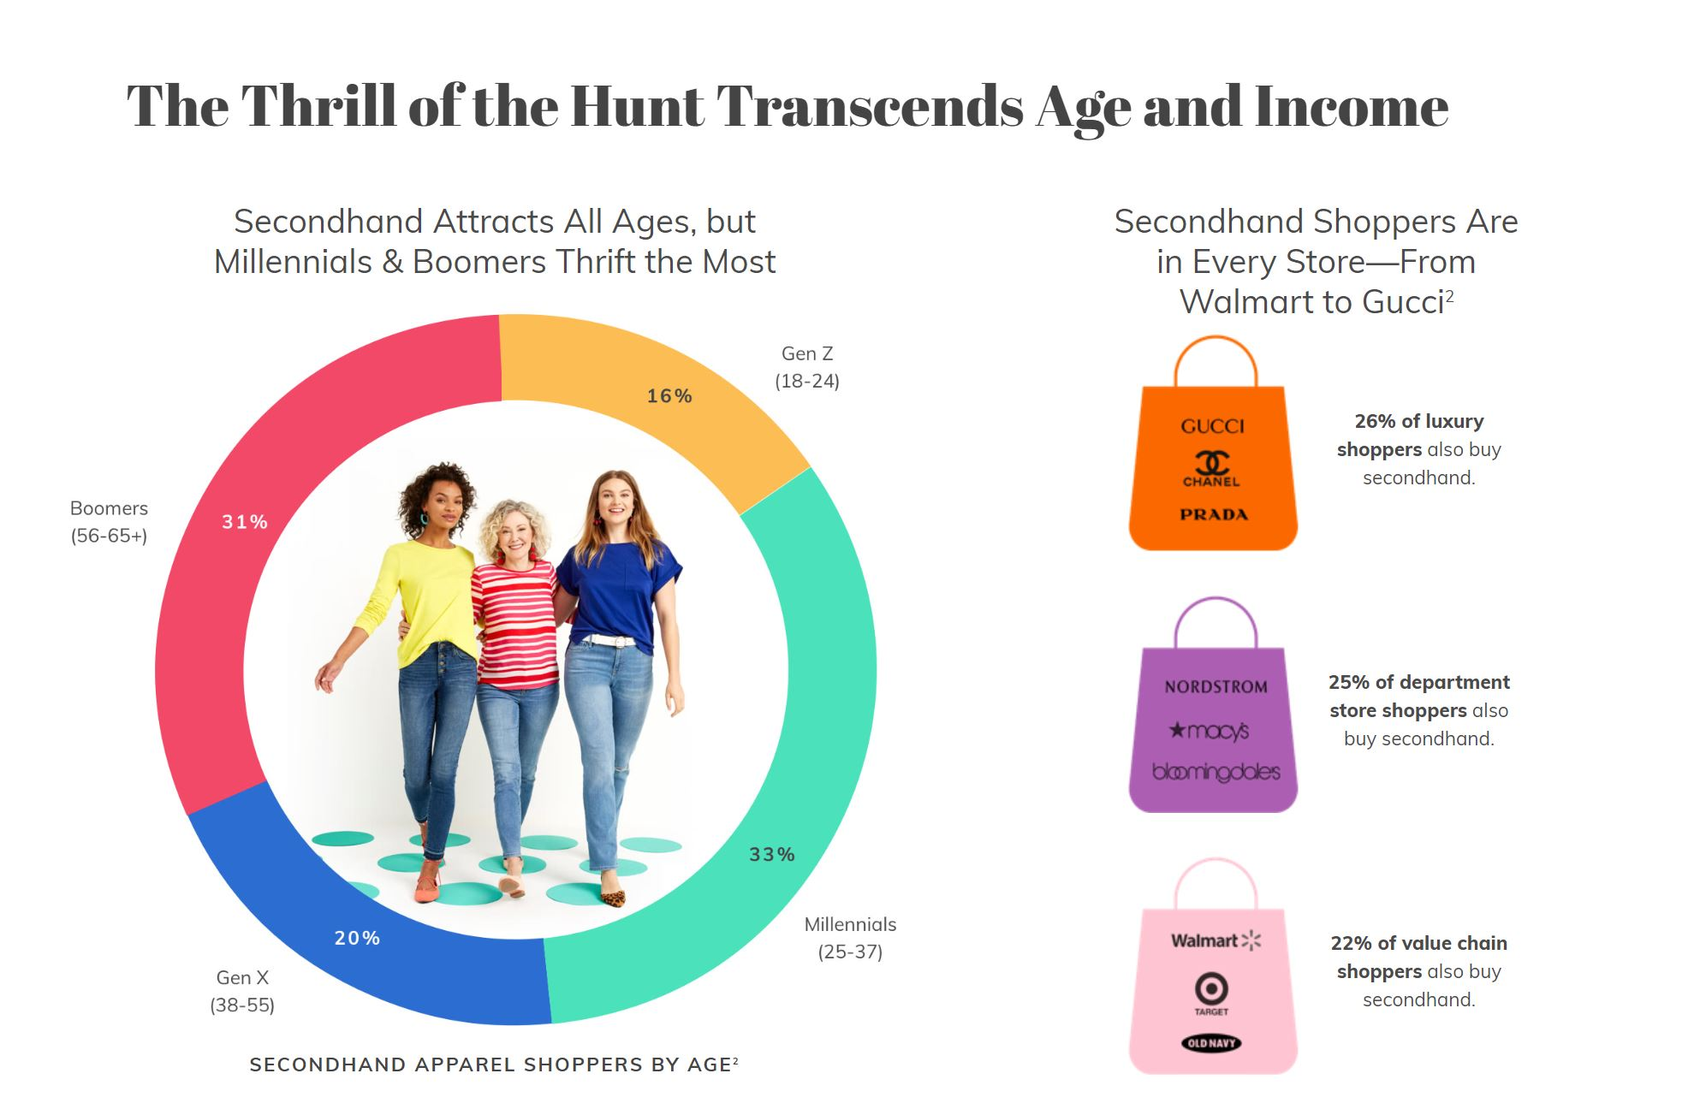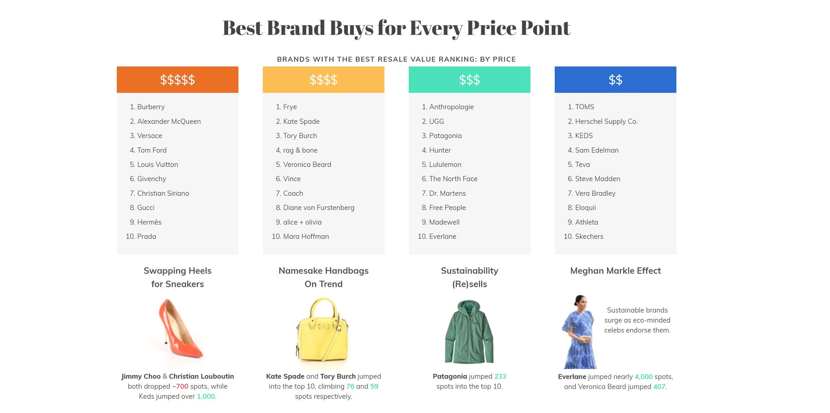
* In 2018, 72% of consumers prefer to shop Eco-friendly.

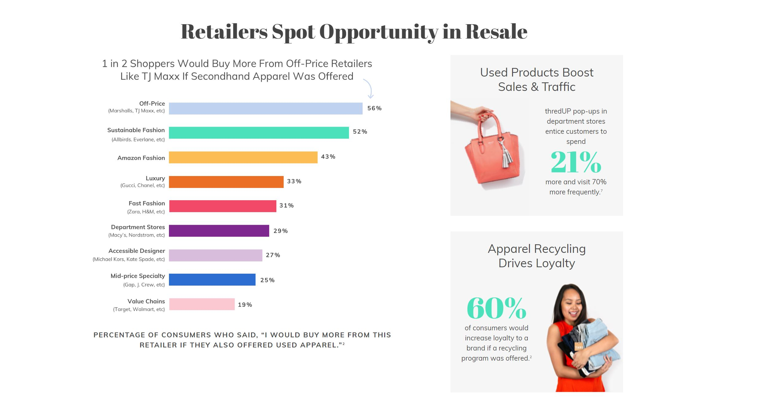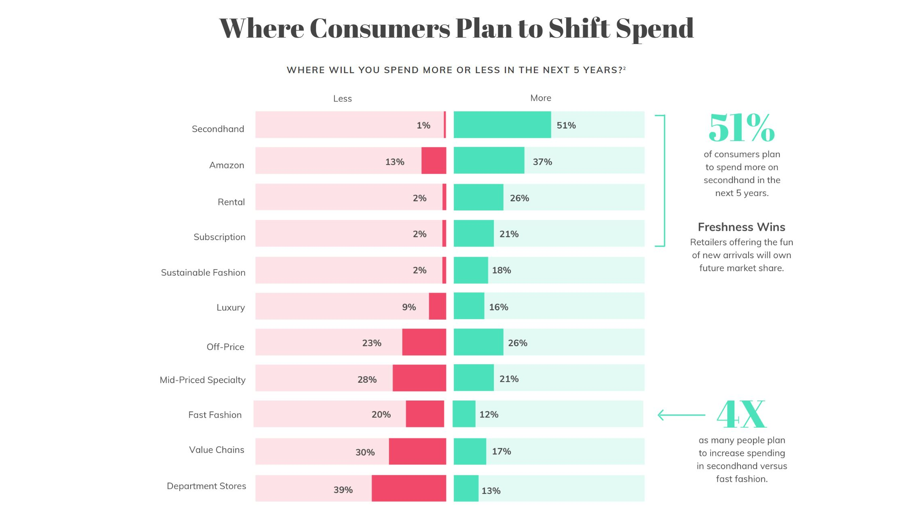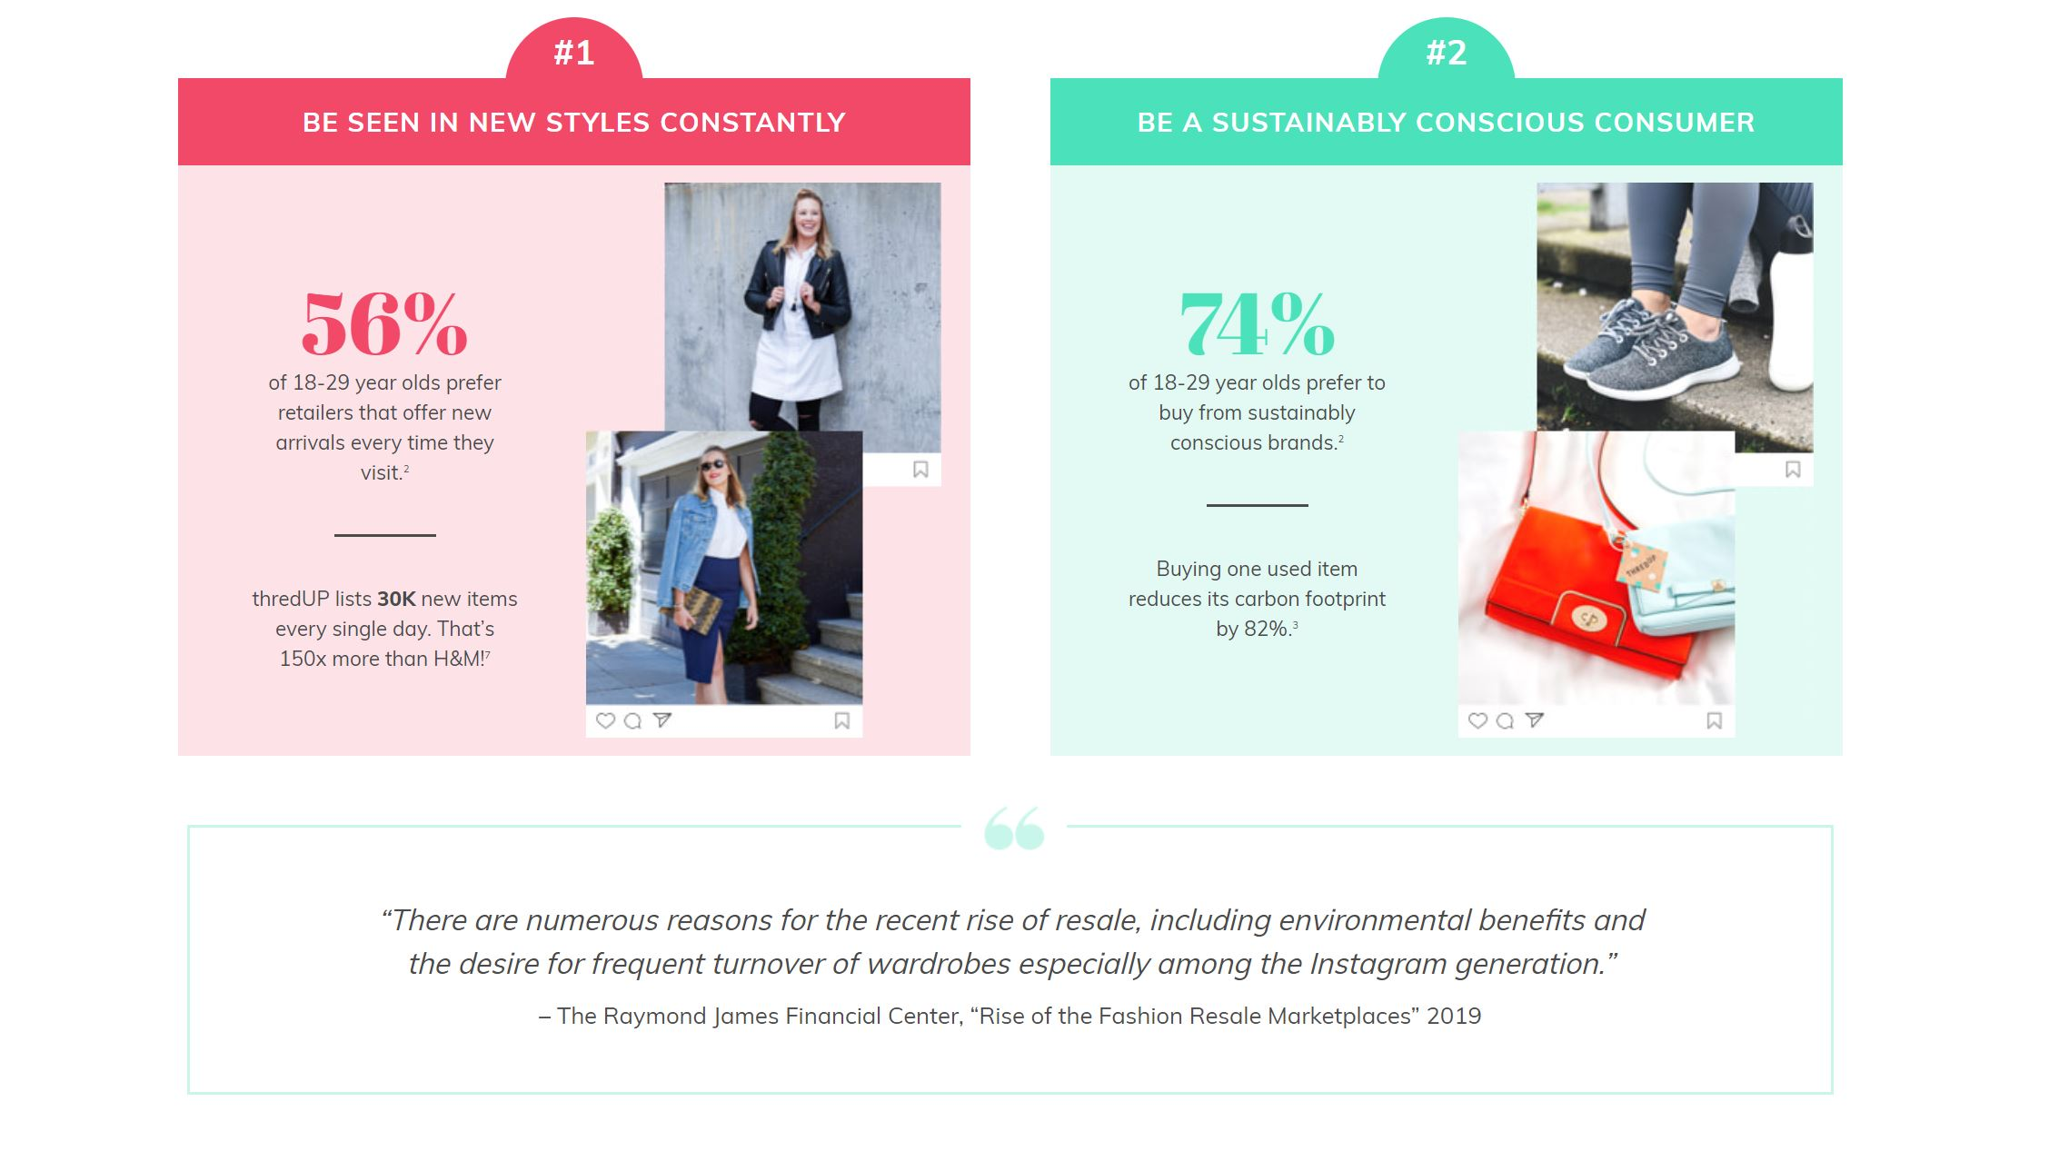

* The Shelf stated that many people shop second hand to obtain luxury brands, as well as affordable ones.
* 12 - 15 percent of Americans will shop at consignment shops.
* The Guardian mentioned how resale stores offer hard to find items at a discounted cost.
* Consignment Mommies mentioned that more consignments stores are dueling warehouse or deadstock sales, which is merging consignment and retail worlds.

In our interview, we discussed with Julie some opportunities she would be interested in. These included bringing in locals and social media opportunities.

Our research included how to bring in locals, the importance of social media advertising, and assessing approval ratings.

**OUR OBJECTIVES BELOW**

|  |  |  |
| --- | --- | --- |
| Bring in locals  (Viroqua & Westby) | Gain opinions on satisfaction in store | To understand social media/online platform importance |

## **RESEARCH DESIGN**

There are three types of design: exploratory, descriptive, and casual.

1. Exploratory research is intended to establish an understanding of a situation/topic, without going into great detail about the objective.

- It is not designed to come up with final answers or decisions.

* An example would be using a hypothesis about what is going on in a situation.

2. Descriptive research tends to answer the who, what, where, and why of the company’s research process.

-It is not based on a hypothesis, strictly finding information that will solve the opportunity. -Descriptive needs to be specific.

3. Causal research is using the cause and effect method when finding the possibilities.

-It works through experimenting to see what is liked and disliked.

Our study included some exploratory research when we were trying to further define the opportunity given to us in our interview with Julie. We reviewed existing literature to learn as much as we could about our client and her business industry.

Through research, we had found that we will be using Descriptive Research.

We decided to search for the who and why people shop at Second Time Around. Our research shed light on possible opportunities for Julie, to see what her current and future customers were seeking or wanted.

We created a survey that addressed these topics both online, as well as in Second Time Around. Using our marketing research knowledge, we found solutions that Julie may find to be useful for her company.

## 

## **DATA COLLECTION METHOD**

*Observation or communication surveys?*

**Observation:** observing actions/behaviors/situations

**Communication:** structured or unstructured surveys

Structured Surveys (Close Ended): are all the same with all the same answers

**Example:** Extremely Unfavorable, Unfavorable, Neither Favorable nor Unfavorable, Favorable, Extremely Favorable

Unstructured Surveys (Open Ended): questions with short answers – opinions

**Example:** What are your thoughts on the new Microsoft Word update? __________ Enter in response

A common resource for collecting primary data: Structured Communication

A common resource for collecting primary data for descriptive research: Unstructured Communication

We used a communication survey mostly unstructured, but partly structured. We decided this because the store does have its busy days and slow days, but we wanted to meet a broader audience on social media. We wanted to know what others think and people are more comfortable answering a survey on their own rather than being rushed and watched over.

- A communication survey is asking for opinions or even constructive feedback to better the store (get interests on what they would like to see in the future, to bring in more customers)

## 

## 

## 

## 

## 

## 

## 

## 

## 

## 

## 

## 

## 

## 

## 

## 

## 

## **SURVEY FORM BELOW:**

What we will be collecting for survey questions and answers:

**Demographics, psychographics, satisfaction rate, feedback.**

1. Please select your age range: Under 18 18-29 30-39 40-49 50-59 60-69 70+

2. Please select your gender: Male Female

3. What is your Zip Code? __________

4. Please circle your **household** income:

|  |  |  |  |  |
| --- | --- | --- | --- | --- |
| Under $10,000 | $10,000 - $29,999 | $30,000 - $49,999 | $50,000 - $69,999 | $70,000 - $89,000 |
| $90,000 - $109,000 | $110,000- $129,999 | $130,000-$149,999 | $150,000 and above |  |

5. Please check all that apply

|  |  |  |  |  |  |
| --- | --- | --- | --- | --- | --- |
| How often do you use these social media platforms? | Never | Rarely | Monthly | Daily | Hourly |
| Facebook |  |  |  |  |  |
| Instagram |  |  |  |  |  |
| Twitter |  |  |  |  |  |
| Pinterest |  |  |  |  |  |

6. What are your feelings about this statement: “Social media ads influence my purchasing habits”

Strongly Disagree Disagree Neutral Agree Strongly Agree

7. Have you ever clicked on a social media post (or ad) to explore a product? Yes No

8. Do you check reviews before shopping at a new-to-you retail store? Please select your answer.

_____ Never _____ Sometimes _____ Often

* Consignment store being a store you can sell used or new items in which the store gives you a small percentage of what they think they can sell it for.

For example, if they think they can sell a shirt for $10 they might give you $5.

9. Have you consigned items to a local consignment store before? Meaning you make a profit if your item sells. Please select your answer.

_____Never(skip to 11) _____Often _____Sometimes _____Always

**\*\*Please turn the page over to continue survey\*\***

10. What types of items do you consign most often at a consignment store? Please select all that apply.

_____Household _____Toys _____Children’s Clothing _____Women’s Clothing _____ Books

_____Men’s Clothing _____Jewelry _____Shoes _____Home Decor _____ Holiday Decor

Other: _____________

11. Please circle if you have ever shopped at a consignment store before? Yes No If no, Why?

If yes, where?

12. What types of items do you buy most often at a consignment store? Please select all that apply.

_____Household _____Toys _____Children’s Clothing _____Women’s Clothing _____ Books

_____Men’s Clothing _____Jewelry _____Shoes _____Home Decor _____ Holiday Decor

Other: _____________

13. Who were you shopping for when at a consignment store? Select all that apply.

____Yourself ____Child(ren) ____Partner ____Friends Other: ___________________

14. What motivates you to shop at a secondhand store? Select all that apply.

____ Eco-Awareness (recycling clothing, etc.) _____ Support locally owned businesses

____ Pricing tends to be lower than retail _____ Unique treasure finds

____ Multiple brands and styles at only one stop ____They sell my items there

____ Many items are new with tags ____ It’s easier to shop by size vs by style

Other: ______________

15. Are you influenced by social media to shop consignment? If so, please check all that apply.

____ Facebook ____ Poshmark ____ Pinterest ____ eBay

Other: __________

16. What additional services could a consignment business offer? Check all that apply

____ Outfit of the day ____ Inspire “Look-alikes” ____ “Closet Clean-outs”

____ Personalized styling sessions ____ Common tips on “Trends on a Budget”

17. When you go shopping for a new piece of clothing or new accessory do you go to a consignment store first? Yes No

18. Please mark how often you might visit Viroqua? Check all that apply.

_____ I live here _____ Weekly _____ Once-Twice a month _____ Once-Twice a year

19. What do you do while visiting Viroqua? Please check all that apply.

_____ I live here _____Visit family/friends _____Work here _____Visit local Coffee Shops

_____Shop Consignment _____ Shop new retail _____Outdoor Activities

_____ Go to the Farmers Market _____Visit local restaurants/bars _____ Entertainment

Other: _______________

20. Have you visited Second Time Around? Yes No (If no, skip to end)

21. Select how you heard about Second Time Around? Select all that apply.

_____ Radio _____ Newspaper _____ Social Media _____ Word of mouth ____Passing by

Other: _______________

22. Please circle the rating on your experience at Second Time Around

|  |  |  |  |  |  |
| --- | --- | --- | --- | --- | --- |
| How satisfied were you with: | Very Unsatisfied |  | Neutral |  | Very Satisfied |
| Finding the store location? | 1 | 2 | 3 | 4 | 5 |
| The store layout? | 1 | 2 | 3 | 4 | 5 |
| With the pricing of the products? | 1 | 2 | 3 | 4 | 5 |
| With the level of customer service? | 1 | 2 | 3 | 4 | 5 |
| With the styles of inventory? | 1 | 2 | 3 | 4 | 5 |
| With the quality of inventory? | 1 | 2 | 3 | 4 | 5 |
| How did you feel when leaving the store? | 1 | 2 | 3 | 4 | 5 |

23. Would it interest you to see more designer brands at a consignment store? Select your answer

_____Nope _____Maybe _____Yes If yes, what brands? ____________________

24. What improvements would you like to see for Second Time Around, if any?

Thank you for taking the time and answering our survey, we truly appreciate it!

**SAMPLING PLAN**

WHO IS YOUR TARGET POPULATION?

*Where did we get that information?*

- Facebook Polls

We had included our survey link to find out who has heard of or visited the store. That way we can get a clear view of who our actual target market is.

From our interview with Julie, we were informed that the common shopper is more mature in age, (40’s to 60’s) mostly females, and some males. Also, they are not locals, they are coming from cities other than Viroqua.

SAMPLE SIZE

*Where and how?*

1. Facebook

-Survey links on three Facebook pages (more information below)

2. Store location

-Survey box with hard copies

3. SoGoSurvey

*How did we get the right type of sample?*

- By having used social media, the Second Time Around Facebook page and our personal pages, we reached more people from the local communities.

*Did we use probability (random) or non-probability (structured) sampling?*

- We used probability sampling because we wanted random answers and a larger demographic in our answers.

We couldn’t keep a really structured survey because in our research we were more curious for general information rather than seeing who knows the correct answer(s) to every question.

*What type of sampling procedure did we use?* (Cluster, convenience, Quota, etc.)

- Our procedure was a “Cluster” procedure, meaning we wanted to keep our sampling population random.

We were striving for multiple diverse answers, as well as yes and no answers. We were also looking for suggestions and feedback.

PLAN FOR WE CONDUCTED OUR DATA COLLECTION

In order to collect the most data possible, we decided to conduct our surveys both in-person and online. We started distributing our surveys on April 9th and ended on April 15th.

Face to Face Survey Collection Information:

To gather information from those who already shop at Second Time Around, Kiersten and Tori spent around two hours at the store on Sunday, April 14th passing out surveys.

* To give off a professional impression we dressed in plain business casual clothing with neutral hair and makeup. This way we came off as approachable in order to make customers feel comfortable being approached by us.

We all decided that in order to make the survey administration unbiased, we had asked every other person that walked in the door if they had five minutes to complete a survey to help benefit Second Time Around.

To continue gathering information after leaving the store, we left a box on the counter with a small description that was as follows:

“Would you mind taking a 5-minute survey to help Marketing students at Western Tech conduct research for Second Time Around?

Please fill out anonymously and leave completed surveys in the box below.

Thank you for your time and honest feedback!”

Online Survey Collection Information:

We chose to conduct our online surveys through SoGoSurvey. With SoGoSurvey, the surveys will be easy to access and straight forward for the users. We have included the link to our final survey below.

Final Survey Link: <https://survey.sogosurvey.com/r/1207hS>

We had reached out to the Second Time Around Facebook page to include our survey on their page with a small description that read:

“Would you mind taking a 5-minute survey to benefit a local business (Second Time Around) in Viroqua? Simply click the link below and provide your honest and anonymous feedback. Thank you for your time.”

Lexi and tori, being from the area, included a link to our survey on their own Facebook pages in order to see what their own family and friends from Viroqua, Westby, and other surrounding local towns responses to the survey will be with a similar description to the one above.

Our group conducted our online surveys on the three Facebook pages from April 9th to April 15th.

* By posting on the Second Time Around Facebook page we will receive feedback from the locals of the town who probably already shop at Second Time Around.
* By posting on Tori and Lexi’s personal pages, we will gather information from both Viroqua locals and locals of the surrounding areas.

Those who come across the survey may not be familiar with the store but may gain interest after discovering the local consignment store.

#### 

#### 

#### 

#### **DATA COLLECTION**

#### *What kind of errors did we get and how did we try to avoid them?*

#### Problem loading survey on a mobile device or laptop:

#### we had included a way to take the survey in the store, in-person to avoid office errors

* Nonresponse was a problem for us for certain questions (15, 22):
  + We tried to combat this by gaining as many surveys as we could

#### 

#### *What was our refusal rate?*

#### Online:

* + Second Time Around Facebook page

Refusal rate = 100% (not seen by people on community page)

* + Lexi’s personal Facebook page

Refusal rate = 88%

* + Tori’s personal Facebook page

Refusal rate = 92%

* In-store: 7 of 50 surveys were filled out on paper

Refusal rate = 86%

(results calculated on April 16, 2019)

#### 

#### *How did we encourage a higher response rate?*

#### Wrote a tagline that the due date was in two days to create a sense of urgency

#### Wrote about the results supporting a local business as well as local students

#### 

#### *What we included in this section of your report?*

#### What our hopes and goals are for this survey and what we want to see for responses

**Following the Sampling Plan**

We followed our sampling plan exactly.

We had posted our survey on three Facebook pages and gathered information from the store surveys that were filled out in person.

One change we had to make was to keep reposting our survey on our own Facebook pages. This was due to the fact that we weren’t getting as many responses as we had hoped for.

In order to keep our surveys unbiased and fair, we asked all survey takers, online and in-store, to complete anonymously.

**Errors & Roadblocks**

We were unable to connect with a Viroqua Facebook page, the “Viroqua Chamber Main Street” to see if they would allow us to post our survey there since they promote local main street business, which Second Time Around is.

Two major roadblocks that we had faced were not being able to get permission to post our survey on the Viroqua Chambers Facebook page, and not getting any surveys from the Second Time Around Facebook page.

Even though we posted it in multiple locations and created multiple posts to encourage people to participate, we still had a couple of response errors:

* skipped/unanswered questions
* low survey turnout

**Data Cleaning Process**

Although we received a good amount of surveys with skipped and unanswered questions, we did not have to exclude any of our surveys. We were able to pull the useful information from all surveys we received.

We collected 40 surveys overall.

**ANALYSIS PLAN**

Research Objectives

Below

|  |  |  |
| --- | --- | --- |
| Bring in locals  (Viroqua & Westby) | Gain opinions on satisfaction in store | To understand social media/online platform importance |

**Counts and Frequency Questions:** 1-21, 23

These questions are designed to help us discover the general statistics of our information. To give us the number of responses per opinion per question...

We gathered these types of information from these questions:

1. Demographics
2. Social Media Usage/Influences
3. Consignment Usage
4. Second Time Around awareness
5. Viroqua Customer Behavior

**Descriptive Statistics** (Mean, Standard Deviation, Mode, Median, Min, Max, ...)

These might be used in questions such as age, income, as well as other questions depending on our survey platform SoGoSurvey.

**Open-Ended Questions:** 3,10,11,12,13,14,15,19,21,23,24

These questions give specific opinions from the survey takers, whether that is from a completely open-ended question or question with a comment or other opinion.

We gathered these types of information from these questions:

1. Specific Opinions
   1. Items
   2. Media
   3. Behavior
   4. Store
   5. Needs/ Wants

**Cross Tabulations Question**: 22

Cross Tabulation helps give specific potential connections between two questions, which gives more detailed data to work with.

We are cross tabulating questions that relate to each other to inform us of more detailed demographic information, etc...

We gathered these types of information from analyzing these two questions together:

1. Improvements
2. Age Satisfaction
3. Who shops at consignments?

*All information below was interpreted from the number of surveys that we had obtained.

## 

## 

## 

## 

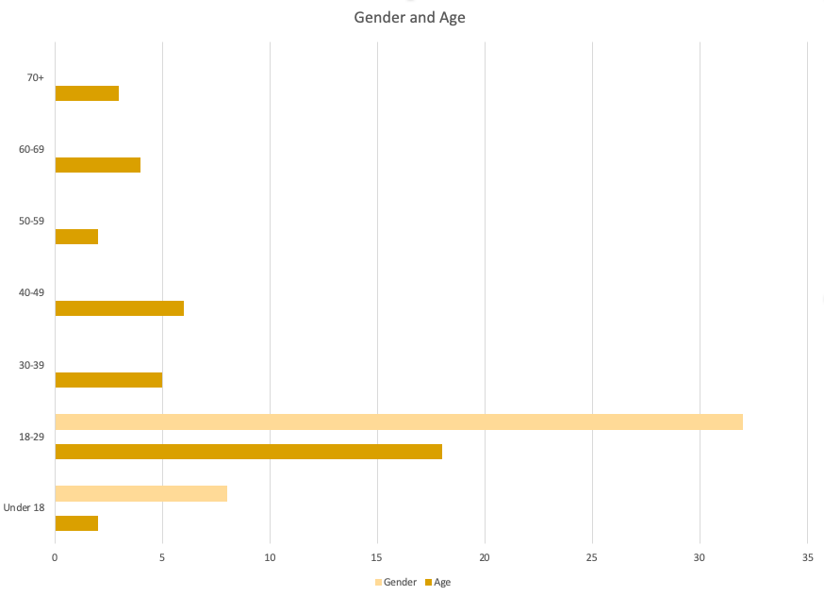This graph shows that the majority of people who took this survey were between the ages of 18-29.

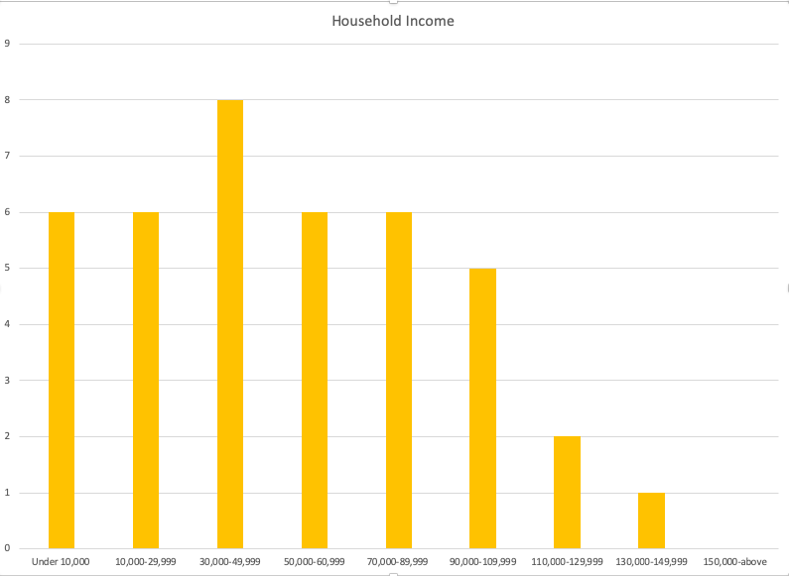

## This graph shows that those with incomes from $110,000 per year and up typically aren’t shopping at Second Time Around.

## 

## 

## 

## 

## 

## Most customers hear of Second Time Around by word of mouth, and least by radio and newspaper ads.

## 

## 

## 

## About 60% of our survey takers have been to Second Time Around.

## 

## 

## 

## 

## 

## 

## 

## 

## 

## 

## While at a consignment store, customers purchase most clothing items and household/decor items.

## 

## 

## 

## 

## Shoppers are most satisfied with inventory, service, and pricing, and less satisfied with the ease of finding the location and store layout.

## 

## 

## 

## 

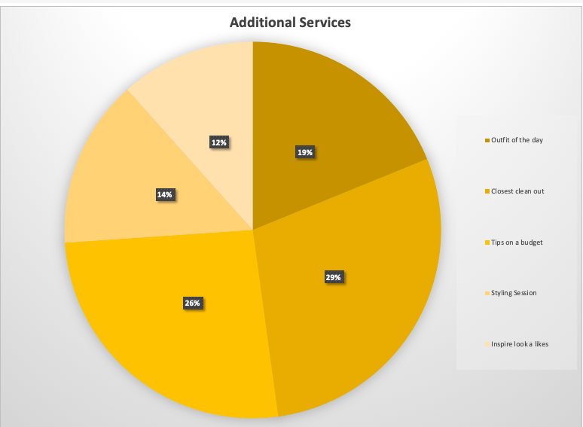

## 

## 29% of shoppers would be interested in a closet cleanout service,

26% of shoppers would be interested in seeing tips for shoppers on a budget as an additional service.

## 

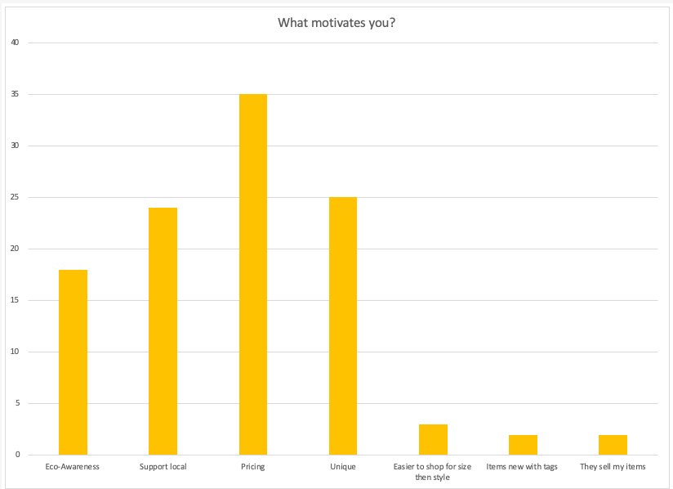When asked what motivates them to shop consignment, most said pricing, unique finds, and wanting to support local businesses.

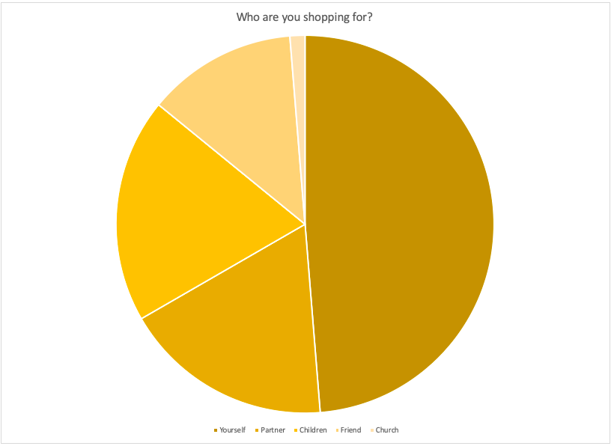

About 48% of secondhand shoppers are shopping for themselves.

About 16% of shoppers are shopping for a partner or children.

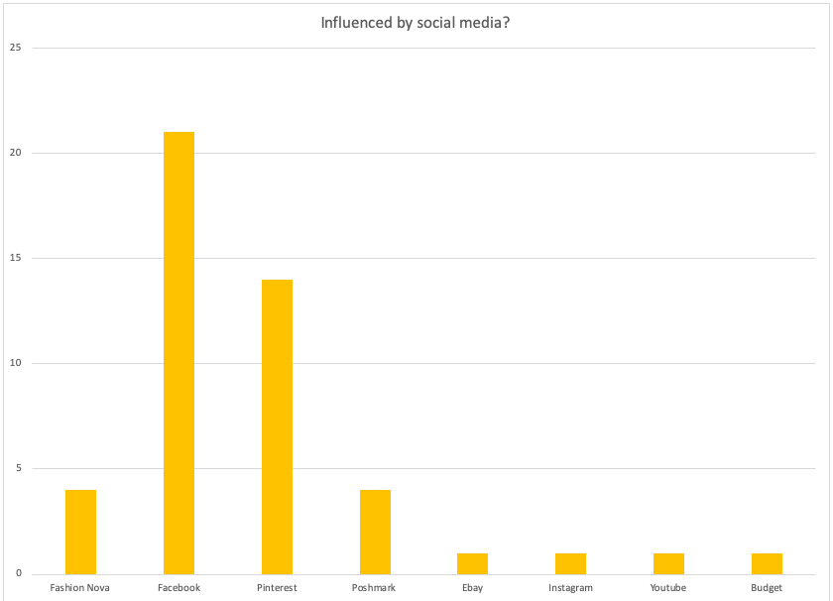

Shoppers in your area are mostly influenced by Facebook to shop at secondhand stores, followed by Pinterest.

## 

## 

## 

## 

## Of those who took our survey, nearly half have consigned items before, and about 40% have never.

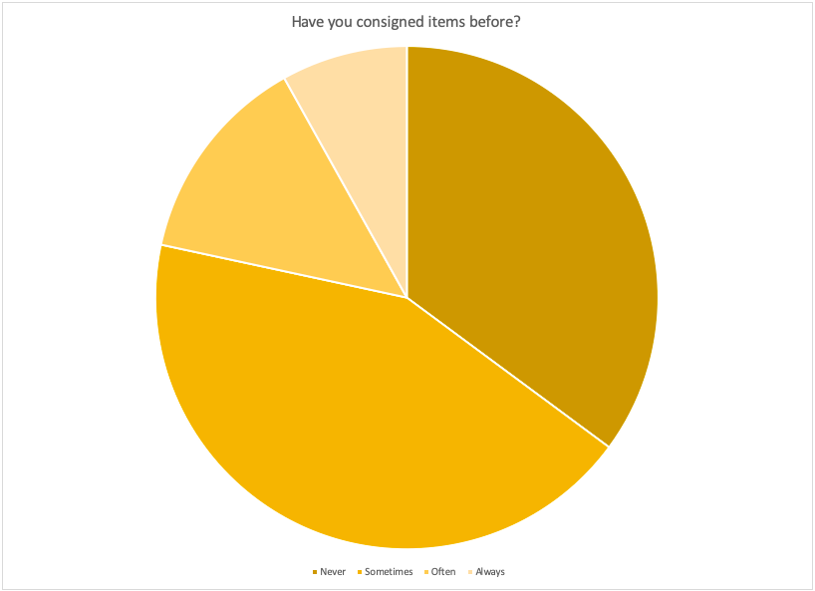

## 

## 

## 

## 63% of local shoppers look at consignment stores before going to a mall or department store to find what they are looking for.

## 

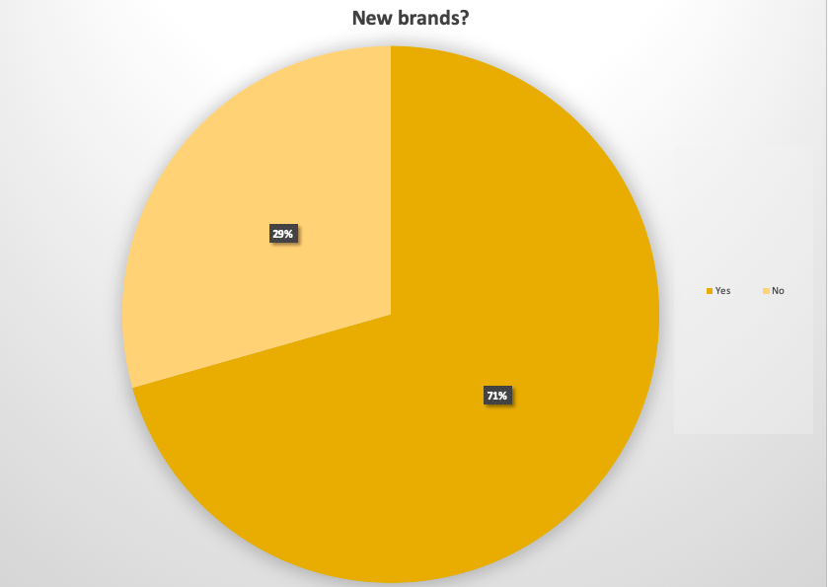

71% of Second Time Around shoppers would be interested in seeing new brands be brought in.

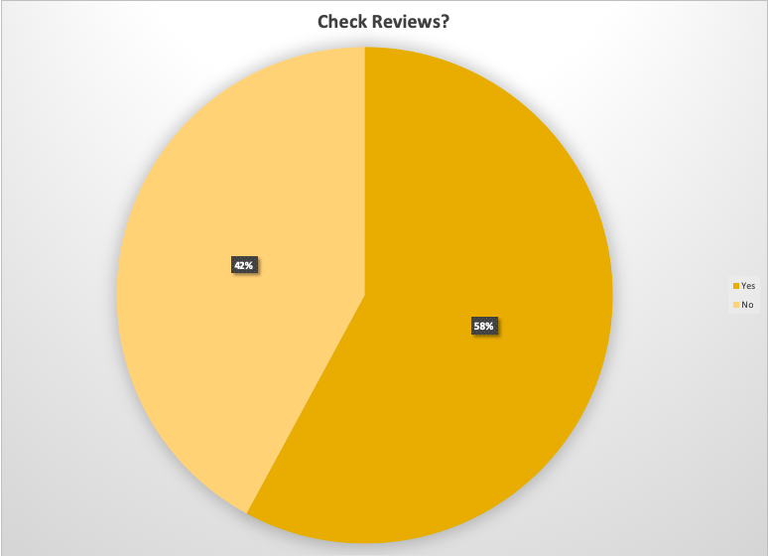

58% of local shoppers check reviews on stores that are new to them before visiting.

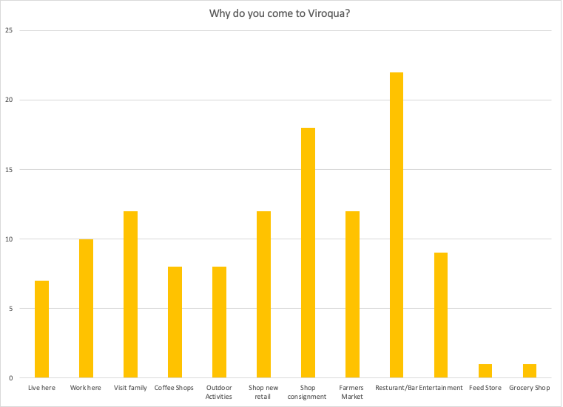

Most people that come to Viroqua are coming primarily for local restaurants/bars and secondarily to shop consignment/secondhand stores.

## **CONCLUSION**

Based on the information we gained from the surveys, there are a few recommendations we believe will help Second Time Around to better cater to their current and future customers.

1. Take in more brands that appeal to a younger generation:
   * For example, Nike, Adidas, American Eagle, etc.

The survey showed us that when people around ages 16-29 go into a second-hand store, they are looking not only for unique finds but also for brands similar to the ones they already wear. 71% of those who took our survey said that they would like to see more brands introduced in the store’s inventory.

2. Increase activity on the Facebook page:

Post more details on the sales of the week or any interesting items that may have come in. This also might be a place for you to share on any “How to shop on a budget tips” you may have.

3. Consider adding Second Time Around on Google Maps:

From the question of overall store satisfaction, we found out that some believe that the location of Second Time Around is difficult to find. Adding your business to Google Maps is an easy fix to make sure that people know how to get directly to your store.

4. Consider starting to use Facebook Ads:

According to our survey, many shoppers are influenced to shop by social media, primarily Facebook. Creating Facebook ads starts free and is easy to measure the progress of. This will help you to reach out to local and surrounding areas of all demographics. The survey told us that many more people are influenced by social media than newspaper or radio ads. A solution could be investing money from one of these platforms to social media advertising.

5. Reach out to local restaurants:

Possibly see if they would be willing to work with you on exchanging flyers to hang in your respective stores to promote each other. We recommend this due to the fact that the majority of people surveyed stated they come to the Viroqua area for the restaurants/bars.

Example: Reach out to Driftless Cafe and maybe offer for you both to put out each other's flyers near the cashier desks. This way you both are helping each other the Viroqua economy.

6. Consider adding additional services:

From our survey, we found out that 29% of second-hand shoppers would be interested in a closet cleanout service, and 26% of shoppers would like to see tips for styles on a budget, as mentioned above (this could include DIY clothing “hacks” for out of date clothing).

Those who have already shopped at Second Time Around were pleased with the customer service and the prices, we found a few opportunities that could help Second Time Around become more widely known and accessible to those of all ages. In a time where second-hand stores are rising in popularity, every new idea is an advantage. With 63% of people saying they shop consignment over department, we believe if you were to implement our recommendations you would have an advantage over other local competitors and increase your business as well.

**Resource Page with Links**

Claritas. https://claritas360.claritas.com/mybestsegments/#zipLookup. Accessed 3 July 2019.

"Consignment vs Resaie | RESTYLE - Women’s Consignment Boutique." Restyle | Women’s Consignment Boutique, 6 May 2019, http://restylefrisco.com/consignment-vs-resale-vs-thrift/.

Dolm, JJ. "9 Reasons Thrift Shopping Helps The Planet and Your Cool Factor." One Green Planet, 26 Feb. 2019, https://www.onegreenplanet.org/lifestyle/why-thrift-shopping-helps-the-planet-and-your-cool-factor.

Ezproxy Login. https://ezproxy.westerntc.edu:2443/login?url=http://www.referenceusa.com. Accessed 3 July 2019.

"How to Get Inventory for a Thrift Store." Bizfluent, 26 Sept. 2017, https://bizfluent.com/how-5931625-inventory-thrift-store.html.

Konrad, Photo. "Vernon County, WI." Data USA, https://datausa.io/profile/geo/vernon-county-wi/. Accessed 3 July 2019.

Leads, Make. "How To Find Your Target Audience In 3 Simple Steps (2019)." Foundation Inc, 3 Feb. 2019, https://foundationinc.co/lab/b2b-target-audience/.

Manganello, Kristin. "Recycling À La Mode: Creating a Circular Fashion System." Thomasnet, 9 Aug. 2018, https://news.thomasnet.com/featured/recycling-la-mode-creating-a-circular-fashion-system.

Mau, Dhani. "2018 Was the Year Resale Went Mainstream." Fashionista, 20 Dec. 2018, https://fashionista.com/2018/12/clothing-resale-sites-apps-market-2018.

"Mr G’s Shoes & Clothing - Viroqua, Wisconsin - Footwear Store | Facebook." Facebook, https://www.facebook.com/pages/Mr-Gs-Shoes-Clothing/146821312008804. Accessed 3 July 2019.

"Pieces of the Past." Facebook, 21 Nov. 2018, https://www.facebook.com/piecesofthepastwi/.

"Retail." GfK Logo, 3 Apr. 2018, https://www.gfk.com/en-us/industries/retail/.

"Second Time Around." Facebook, https://www.facebook.com/pages/category/Clothing-Store/secondtimearoundviroqua/about/. Accessed 3 July 2019.

Secondtimearound.Net. http://www.secondtimearound.net/. Accessed 3 July 2019.

"U.S. Census Bureau QuickFacts: Vernon County, Wisconsin." Census Bureau QuickFacts, https://www.census.gov/quickfacts/fact/table/vernoncountywisconsin/PST045218. Accessed 3 July 2019.

Versium REACH - Datafinder Is a Service of Versium. https://datafinder.com/products/versium-reach. Accessed 3 July 2019.

"Young, Underemployed and Optimistic." Pew Research Center’s Social & Demographic Trends Project, 9 Feb. 2012, http://www.pewsocialtrends.org/2012/02/09/young-underemployed-and-optimistic/.

THIS IS THE TRENDS LINKS

<https://www.thredup.com/resale>

<https://consignmentmommies.com/ten-trends-in-consignment-you-should-be-excited-about/>

<https://www.theguardian.com/business/2016/sep/17/consignment-stores-upscale-designer-clothes-resale-trend>

<https://www.theshelf.com/the-blog/resale-industry-recommerce-stats>

<https://www.forbes.com/sites/richardkestenbaum/2018/04/03/secondhand-clothes-are-a-threat-and-an-opportunity/>.